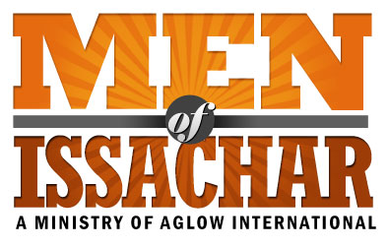
MOI LEADERSHIP QUESTIONNAIRE
(INTERNATIONAL)
Name of Group:
Name: Date:
Address:
City: Nation:
Post Code:
Phone: Home: Cell: __________________
Email:
Date of Birth: (day / month / year)

New MOI Group Existing MOI Group Co-Leader Leader
I agree to these statements:

I have accepted Jesus Christ as my personal Lord and Savior.

I have read and agree with the Aglow International vision and mission statements.

I attend church regularly

If I have ever taken part in any occult activities, I have renounced such teachings and
have asked God to forgive me.

I live a moral and upright life according to Biblical Standards found in Galatians 5:16-26

I agree to become a Global Partner of Aglow in my nation or through Aglow International*

Are you baptized in the Holy Spirit with evidence of speaking in tongues? Yes No

When? _______________________________________________________________________

Church attending? ____________________________ For how long? ______________________

Church Denomination: ___________________________________________________________

Do you have someone who regularly encourages, mentors, and/or admonishes you (Romans 15:14)? Yes No

What is your relationship to that person?

*If you wish to sign up for Global Partnership through Aglow International, please visit: https://aglow.org/become-a-global-partner/ or contact your National President to help you in becoming an Aglow Global Partner. An annual membership is: $30 USD

Please submit this form to your Aglow National Leader
Or,
If you do not have a National Leader,
please send form to Aglow’s International Field Director,
Janae Lovern JanaeLovern@aglow.org.

Aglow National Leader Approval:

___________________________________________________ Date: __________________
National Leader Signature

National Leader Name: ____________________________________________

National Leader: Please mail signed & completed form to:
(or scan & email to JanaeLovern@aglow.org)
Janae will give a copy of approved forms to MOI Director, Dave McDaniel for approval prior to completing official affiliation paperwork.

Aglow International
Attn: Janae Lovern, International Field Director
PO Box 1749
Edmonds, WA 98020

