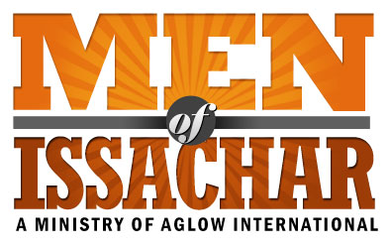

MOI Leadership Questionnaire
(USA)
Name of Group: _____________________________________________________________
Name: _________________________________________________Date: ______________
Address: _______________________________________________
City: ________________________ State: ___________________ Zip Code: ________
Phone: Home: ___________________ Cell: __________________
Email: ________________________________________________________
Date of Birth: _________________________
(day/month year)

New MOI Group Existing MOI Group Co-Leader Leader
I agree to these statements:
I have accepted Jesus Christ as my personal Lord and Savior.

I have read and agree with the Aglow International vision and mission statements.

I attend church regularly

If I have ever taken part in any occult activities, I have renounced such teachings and
have asked God to forgive me.

I live a moral and upright life according to Biblical Standards found in Galatians 5:16-26

I agree to become a Global Partner of Aglow in my nation or through Aglow International*

Are you baptized in the Holy Spirit with evidence of speaking in tongues? Yes No

When? _______________________________________________________________________

Church attending? ____________________________ For how long? ______________________

Church Denomination: ___________________________________________________________

Do you have someone who regularly encourages, mentors, and/or admonishes you
(Romans 15:14)? Yes No

What is your relationship to that person? ____________________________________________

*If you wish to sign up for Global Partnership through Aglow International, please visit: https://aglow.org/become-a-global-partner/ or contact your Area Team President (or Regional Director) to help you in becoming an Aglow Global Partner. An annual membership is: $30 USD

Please submit this form to your Aglow Area Team President or Regional Director
Or,
If you do not know how to contact your Area President/Regional Director
please send form to Aglow’s Men of Issachar Director
DaveMcDaniel@aglow.org

Aglow Area Team/Regional Director Approval:

___________________________________________________ Date: __________________
Signature

Leader Name: _______________________________________ Position: ________________

Area Team President/Regional Director: Please mail signed & completed form to:
(or scan & email to DaveMcDaniel@aglow.org)

Aglow International
Attn: Dave McDaniel
PO Box 1749
Edmonds, WA 98020

